FAQ: Outlook Error

Update to 64bit

| September-20 |

**Document Overview**

**Documentation Goals**

This documentation is intended to provide instruction for ***(XYZ – REPLACE WITH DOC Function)****.*

**Documentation Disclaimers**

* Teach a user how to utilize or develop in Progress.
* Provide instructions for creating or administering and Advantzware Progress Database.
* Provide application Support for other Advantzware functions.

**Special Terminology**

* ***REPLACE/LIST any special terminology for the document***

**Table of Contents**

**How to Solve Email Errors After an Outlook Update** 3

Possible Error Messages: 3

How to Determine Outlook Version 3

Solution 5

Step One: Update XPMail Software 5

Step Two: Outlook Permission Rules 5

# **How to Solve Email Errors After an Outlook Update**

## Possible Error Messages:

* “You don’t have a mail system available.”  
  SCREENSHOT
* “A program is trying to access Outlook. Are you sure you wish to run it?”  
  SCREENSHOT

This issue is a result of an update in the Microsoft Outlook software, changing it from using an older 32bit version, to a newer 64bit version. Going forward, Outlook will default to using the 64bit version, and users will need to follow the directions in this FAQ in order to successfully navigate the changes.

Both Server and Workstation versions of the Advantzware software use a program called XPMail, which acts as a bridge between our software, and Microsoft Outlook. Currently, this bridge program is installed as a 32bit program as well, and works with the older version of Outlook.

When a user updates to the newest version of Microsoft Outlook, the 32bit version of XPMail that is currently installed on all systems will no longer be allowed access, as it runs with far less RAM capabilities than the newest Outlook will need in order to perform efficient processes.

## How to Determine Outlook Version

1. Open Microsoft Outlook  
   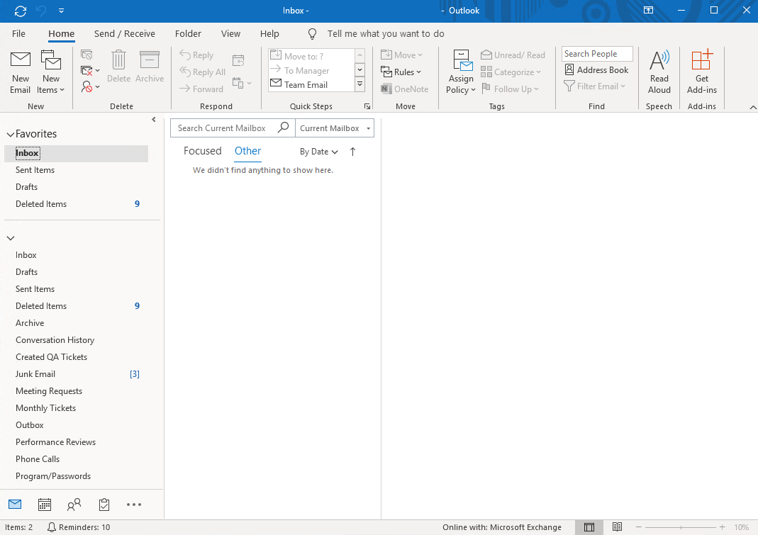
2. Click on the ***“File”*** tab at the top of the page.  
   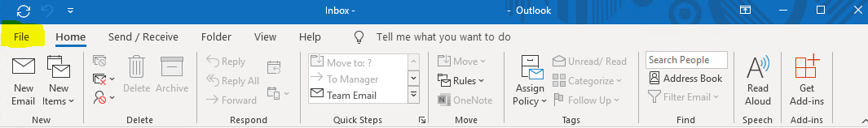
3. Click the ***“Office Account”*** tab along the left-hand side of the screen.  
   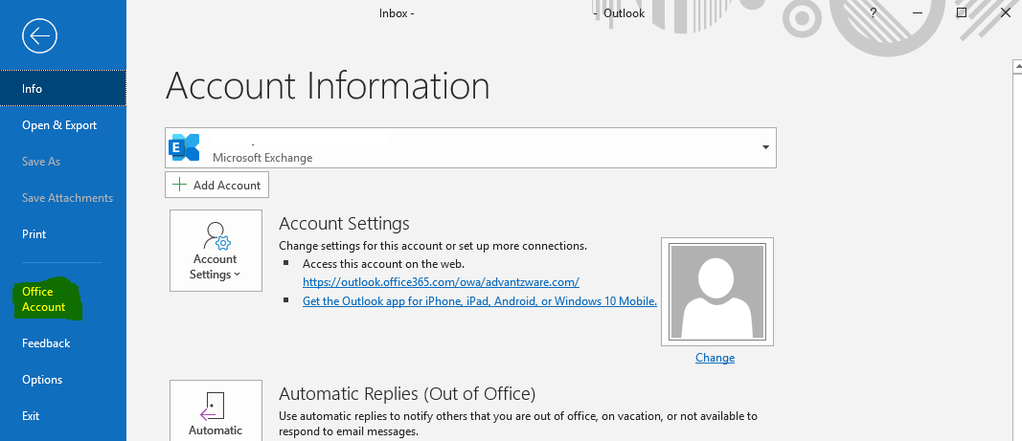
4. Click the ***“About Outlook”*** button.  
   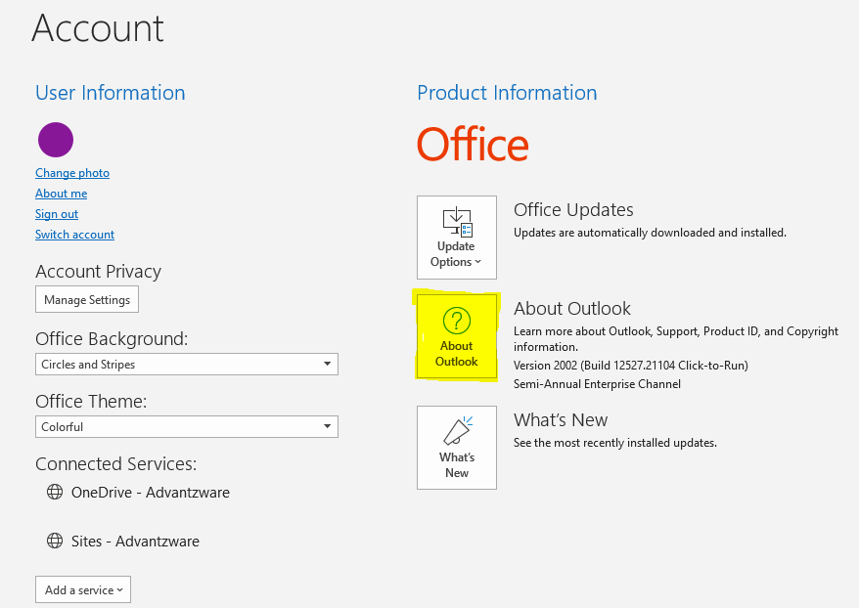
5. At the top of this screen, the current Outlook version will clearly state if the user is currently using a 32bit or 64bit version.  
   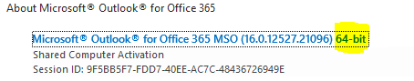

## Solution

The solution is to upgrade current versions of XPMail to the more robust 64bit version. This version of the bridge program will work with both Advantzware Server and Workstation programs seamlessly, but is the only version that will be able to communicate with the newest version of Outlook.

### Step One: Update XPMail Software

* The executable installation file for the 64bit version of the XPMail software is located on the Server “N” Drive, under Installs/XPMail2_5.exe
* Alternatively, you may download the program easily from the following link on out “Patches” webpage. (Linked Here: XXX)

### Step Two: Outlook Permission Rules

The newest versions of Microsoft Outlook have sensitive internal security systems to determine which programs it can be allowed to work with. Users will have to bypass this system in order for XPMail to seamlessly integrate with the Outlook program.

If this “allowable programs” security system is not bypassed, the user is likely to experience the following error message when attempting to create any kind of email within the Advantzware system.

* “A program is trying to access Outlook. Are you sure you wish to run it?”  
  SCREENSHOT

Please Note: While the user can allow access at this point, the permissions will only last a short amount of time. Once this time runs out, the error message will begin to reappear. In order to bypass this system, the user should take the following steps:

1. Open Microsoft Outlook  
   
2. Click on the ***“File”*** tab at the top of the page.  
   
3. Click the ***“Options”*** tab along the left-hand side of the screen.  
   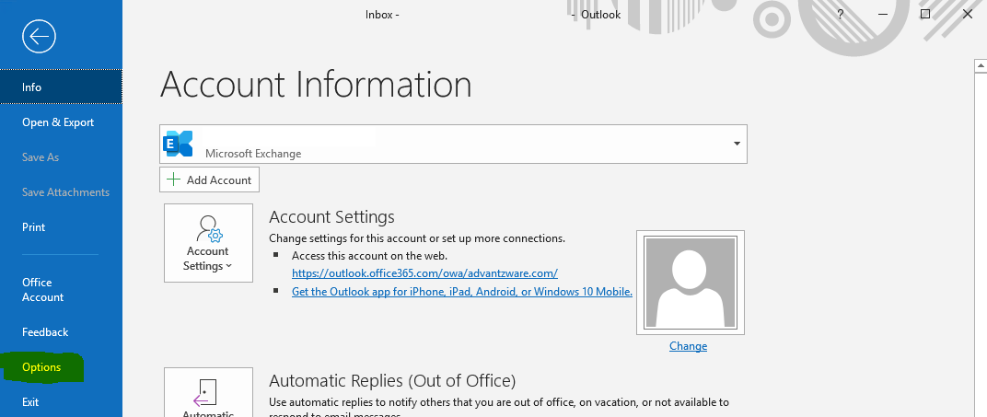
4. Click the ***“Trust Center”*** tab along the left-hand side of the screen.  
   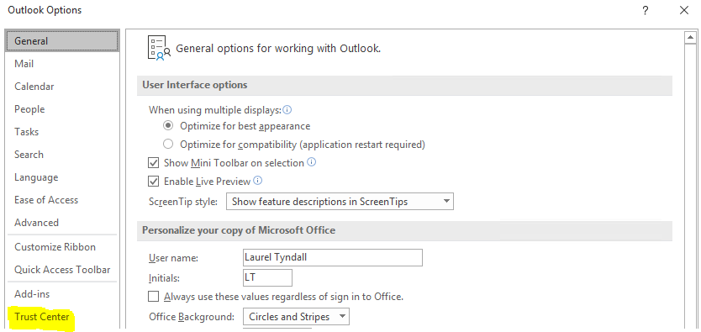
5. Click the ***“Trust Center Settings”*** button.  
   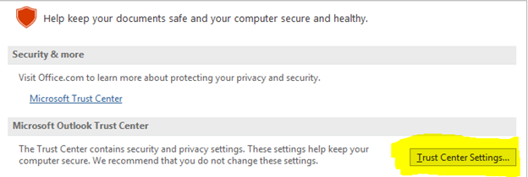
6. Click the ***“Programmatic Access”*** tab along the left-hand side of the screen.  
   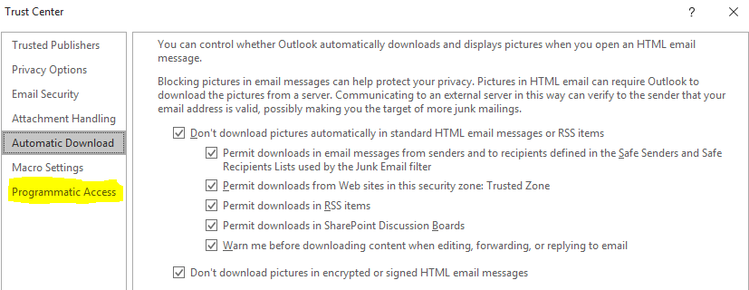
7. Make sure that the choice bubble next to the “Never warn me about suspicious activity” option is toggled.  
   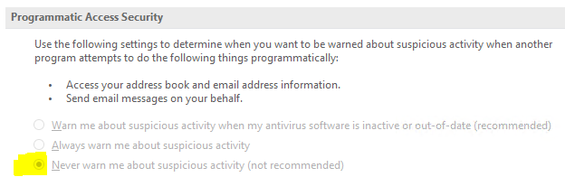  
     
   Please Note: If the text on this page is grayed out (as pictured above), this means that the current user does not have access to make these security changes. In this case, the user will need to contact the Microsoft Office 365 administrator in order to allow access to the security choice.